CRN Agency Winter Meeting - 2013

Date: Thursday 24th January 2013, 09:00 – 16:00

Venue: Room E0.05 (ground floor of the John Dalton Building)

School of Science and Environment, Manchester Metropolitan University

Programme

09:00 Arrive – tea/coffee

09:25 Minutes from September meeting

09:30 CRN Management Group

A) Items for decision by members:
    - Management group terms of reference – paper 1
    - Service Level Agreement 2013/14 – paper 2
    - Communications proposal for journal and website – paper 3
    - Membership fees and benefits proposal – MMcC verbal report
    - Proposed budget for 2013/14 – paper 4

B) Items to note:
    - Finance report 2012/13 – paper 5
    - Update on March 2013 Conference – KC verbal report
    - CRN activity calendar 2013/14 (15 months) – paper 6

10:00 Information Exchange - based on proformas

Discussion, links to proposed ‘Industry Insights’ and any follow up actions

11:30 Tea / Coffee

11:45 CRN role and input into research

During this discussion-based session we will be asking 'what role can CRN usefully play in bringing the research and evidence gathering community together and how might we do this?’ We hope to establish a clear view of what value CRN would bring in fulfilling a convening/coordinating role.

MMU hosts Simon Caporn and Philip Wheater will join the discussions, which will provide a useful academic sector touchstone for our deliberations.

12:45 Lunch

13:45 Funding Seminar

National Trust Euro successes and the opportunities for financing Countryside Projects from the EU in the Future, Phil Lakin, National Trust

Phil is the European Grants Manager at The National Trust. He will provide an overview of countryside-related projects for which the Trust has secured funding in the past. He will also update the group on the future potential for securing EU funding for countryside projects.

14:10 BIG investment to 2015 – an overview of funding, Tessa Wiley, Policy and Learning Manager, BIG Lottery Fund

Tessa is responsible for gathering regional intelligence through research and stakeholder engagement and feeding this into investment design and decision making. She has also overseen the roll out of a number of strategic investments across the North West region, and been involved in establishing the Regional Funders Forum.

14:35 Tea/coffee

14:50 HLF strategic framework / priorities for the future, Drew Bennellick, Head of Landscape and Natural Heritage, Heritage Lottery Fund

Drew is responsible for HLF policy, strategy and expert advice in relation to designed landscape and natural heritage projects in the UK.

15:15 Discussion and concluding remarks

15:45 Tea and Depart

Relevant Notes

Directions:
The postcode for our meeting venue is M1 5GD.
The entrance is from the Chester road down the side of the John Dalton Building.

5min walk from Oxford Road Station: 16min walk from Piccadilly Station:
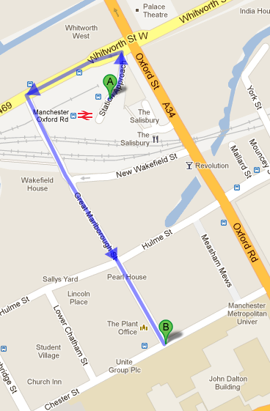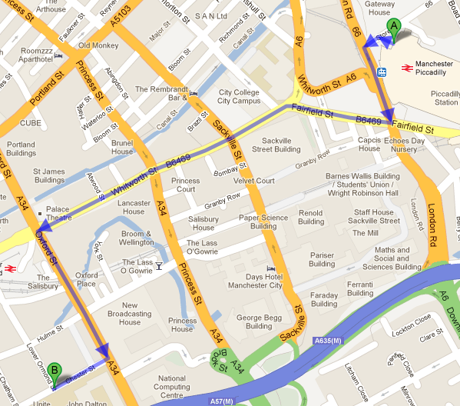

Accommodation:
CRN is holding an allocation of rooms at the Ibis, Portland Street. The cost is £49.00 plus £7.50 for breakfast. Rooms can be booked through the CRN secretariat and this rate is available on a first-come first-served basis.

To view the hotel click here: http://www.ibis.com/gb/hotel-3142-ibis-manchester-centre-portland-street/index.shtml

Evening meal (23rd Jan):

CRN will be reserving a table for dinner (near the Ibis) on Wed 23 January, 6pm. Please advise if you would like to join us.

Lunch (24th Jan):

Members will be charged £12pp for lunch. This will be invoiced after the event by the CRN secretariat (c/o Outdoor Recreation NI)

ENDS

Version 2

12.12.12

